**Design/Practical Experience [MEN1010]**

**Department of Mechanical Engineering**

**Final Report**

Academic Year: 2021 – 2022

Semester: Summer

1. **Title:**

Estimation of Laminar Burning Speed using Machine Learning Algorithm

1. **Author’s and Mentor’s Names:**

Author’s name: Rohit Nagar(B19ME069), [Khushal Sonawat (B19ME037)](mailto:sonawat.1@iitj.ac.in)

Mentor’s name: Dr. [Sudipto Mukhopadhyay](mailto:smukhopadhyay@iitj.ac.in)

1. **Introduction:**

Due to the development of new technologies, the elaboration of alternative fuels to petroleum fuels in internal combustion engines has been necessary. Natural gas, mainly made up of methane with some % of the Hydrogen, is part of this family of fuels because of the lower level of emissions in terms of CO, 𝐶𝑂2, HC, and ${NO}_{2}$. Due to Hydrogen reactivity, Mixing it with natural gas can improve thermal efficiency, increase burning velocity, extend the flammability limits and reduce pollutant emissions because of a higher Hydrogen/Carbon atomic ratio. Thus, for the design of spark-ignition engines, an accurate computation for the laminar burning speeds is mandatory. It is a key parameter to describe the fuel properties i.e. the Equivalence Ratio, Temperature, and Pressure of the unburned gas mixture.

1. **Design Problem Formulation:**

For the accurate computation of the Laminar burning speed, a human brain is not sufficient. By physically solving the equation also can produce a large error that is not sustainable for the industry to design the Spark Ignition Engine. To overcome this problem, we aim to design a Machine Learning model to compute laminar burning speed(SL).

1. **Possible methods to solve the problem:**
2. Different chemical kinetic models and laminar flame speed correlations are developed for its prediction and to approximately describe the mixture behavior in the engine combustion chamber. But these existing model contains the property that depends individually due that computation may go complex.
3. we use different machine learning models for the accurate computation of the laminar burning speed cause these models to prons to the less error.

1. **Dataset for the project:**

Our first important task is to generate the dataset for the Machine learning models. To

generate the datapoint we choose the plots[1] and apply simulation from the known Webplotdigitalizer [2]. Now we have around 700 data entries for training and testing the models.

Since the modus operandi was online, we had this limitation to the access of equipment. Thanks to WebPLotDigitalizer that helped us generate our dataset through the graphs and plots. The dataset extracted can be found here. The process of extracting the data is shown in the GIF below.



1. **The methodology adopted for the project:**

We know that we have to predict laminar burning speed based on several parameters. Laminar Burning speed is a numerical value therefore we have to deal with the regression problem. We use a Support vector machine, Linear Regression, and DecisionTreeRegressor for the computation speed. A model with the least squared error is selected.

Similar to the accuracy, we find the Root mean Squared error(RMSE) between actual burning speed and predicted speed as follows:

$rmsⅇ=\sqrt{\frac{1}{n}\sum_{i=1}^{n}{}{\left(x_{i}^{'}-x_{i}\right)}^{2}}$

, where x is the Actual laminar burning speed and x’ is the predicted laminar burning speed.

1. **Result and Analysis:**

**1. Laminar burning speed vs. Fuel-air Equivalence ratio:-**

We analysis of the equivalence ratio effect on the laminar burning speed The plots refer to the laminar burning speed predicted with the Machine Learning Model having the least Root Mean squared error.

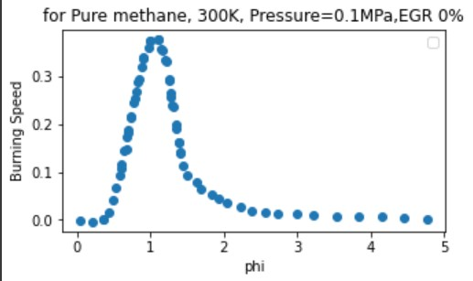

figure-1

In figure-1, it is possible to see the trend of 𝑆𝐿 computed by models. The level of temperature and pressure is fixed correspondingly at 300 K and 1 bar, EGR rate is set to 0% and also mixture contains 100% methane and 0% Hydrogen.

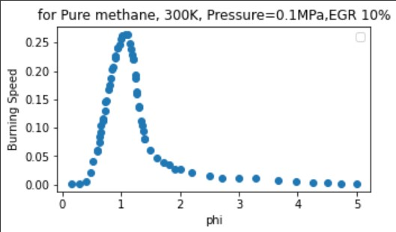

figure-2

In figure-3, The trend of 𝑆𝐿 computed by models. The level of temperature and pressure is fixed correspondingly at 300 K and 1 bar, EGR rate is set to 10% and also mixture contains 100% methane and 0% Hydrogen.

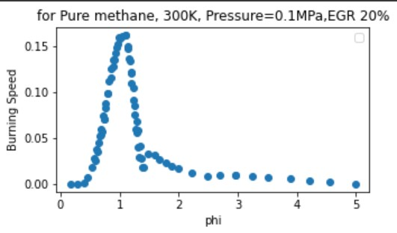

figure-3

In figure-3, The trend of 𝑆𝐿 computed by models. The level of temperature and pressure is fixed correspondingly at 300 K and 1 bar, EGR rate is set to 20% and also mixture contains 100% methane and 0% Hydrogen.

**2. Laminar burning speed vs. pressure:-**

In this section, the analysis of the pressure effect on the laminar burning speed will be treated. It will be plotted in function of different levels of pressure.

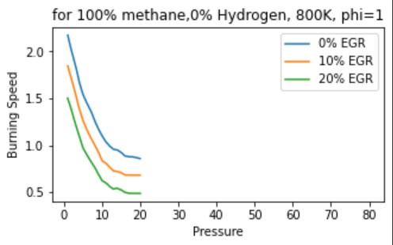

figure:-4

In figure-4, The trend of 𝑆𝐿 computed by models. The level of temperature and Equivalence ratio is fixed correspondingly at 800 K and 1, also the mixture contains 100% methane and 0% Hydrogen.

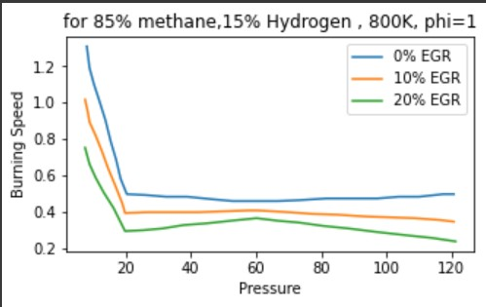

figure:-5

In figure-5, The trend of 𝑆𝐿 computed by models. The level of temperature and Equivalence ratio is fixed correspondingly at 800 K and 1, also the mixture contains 85% methane and 15% Hydrogen.

**3. Laminar burning speed vs EGR:-**

In this section, the analysis of the EGR effect on the laminar burning speed will be treated.

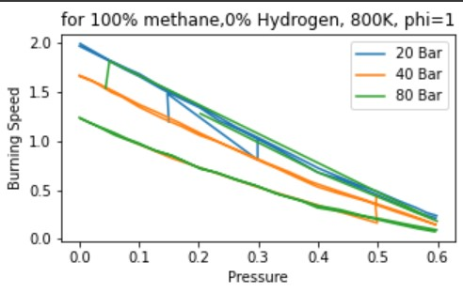

figure-6

Laminar burning speed vs. EGR at φ=1,800K, pure methane mixture at 20 bar, 40 bar, 80 bar;

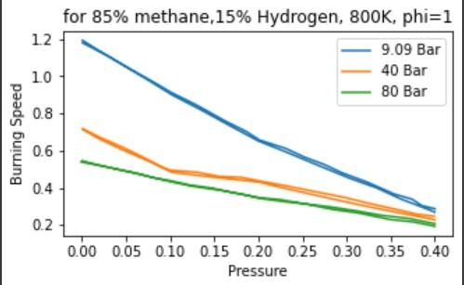

figure-7

Laminar burning speed vs. EGR at φ=1,800K, 85%CH4 and 15%H2 mixture at 9.09 bar, 40 bar, 80 bar

figure-6 and figure-7shows an exponential correlation and with a high level of residual in the combustion chamber, the laminar flame speed decreases.

1. **Conclusions:**
2. We predict the Laminar Burning speed based on Various parameters such as Equivalent air-fuel ratio(phi), Pressure(Bar), EGR rate, % methane and hydrogen, etc. also involves training and testing of Multiple machine learning Models. For the development of such models, we get around 700 data entries from simulations, then we train the model and assess the best regression model between Linear Regression, Multi-Level Perceptron (Neural Networks), Support Vector Machines.
3. As consequence, this latter can generate predicted responses for each new dataset if they are organized with the same number of input arguments given during the training activity. After that, the prediction capability of this model is checked making another comparison, in correspondence of two specific working points, between the laminar burning speed obtained by the application of machine learning and actual value.
4. We compared the predicted data with actual data by varying pressure, unburned gas temperature, fuel-air equivalence ratio, EGR rate, methane, and hydrogen concentration in the mixture. The Linear Regression model turned out to be the best for the purpose of prediction with 5% inaccuracy.
5. The choice of programming language for machine learning is quite important; We use python programming language due to its “flexibility” and less resource consumption nature.

1. **References:**

[1] Amirante R, Distaso E, Tamburrano P, Reitz RD. Laminar Flame Speed Correlations for Methane, Ethane, Propane and their Mixtures, and Natural Gas and Gasoline for Spark-Ignition Engine Simulations. Int J Engine Res 2017: In press.

[2] Gülder ÖL. Correlations of laminar combustion data for alternative SI engine fuels. SAE Tech Pap 841000 1984.

[3] R.Amirante, E.Distaso, P.Tamburrano, R.D.Reitz. Analytical Correlations for Modeling the Laminar Flame Speed of Natural Gas Surrogate Mixtures

Signature of Student Signature of Supervisor